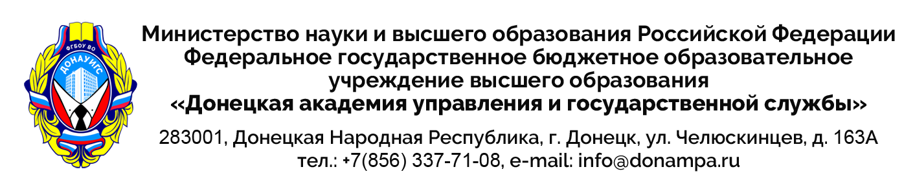

|  |  |  |  |  |
| --- | --- | --- | --- | --- |
|  | | № |  |  |
| На № |  | от |  |